10.4 Identifying influential cases – DFFITS, Cook’s distance, and DFBETAS measures

Once outlying observations are identified, it needs to be determined if they are influential to the sample regression model.

Influence on single fitted value – DFFITS

The influence of observation i on 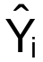 is measured by:
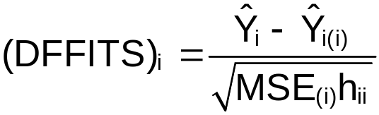
“DF” stands DIFFerence in FITted values.

(DFFITS)_{i} ≈ the number of standard deviations by which changes when observation i is removed from the data set.

DFFITS can be repressed as: :
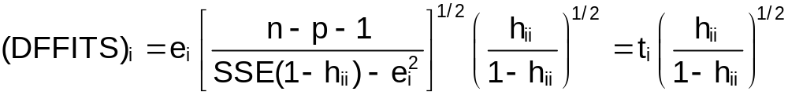Therefore, only one regression model needs to be fit.

Guideline for determining influential observations:
- |(DFFITS)_{i}|>1 for “small to medium” sized data sets
- |(DFFITS)_{i}|>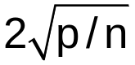 for large data sets

Influence on all fitted values – Cook’s Distance

Cook is a graduate of Kansas State University and is a professor at the University of Minnesota.

Measures the influence of the i^{th} observation on ALL n predicted values.

Cook’s Distance is:
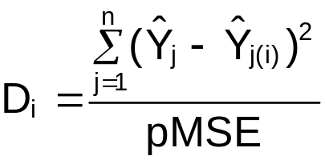
Notes:
- The numerator is similar to (DFFITS)_{i}. For Cook’s Distance, ALL of the fitted values are compared.
- The denominator serves as a standardizing measure.

Cook’s Distance can be repressed as:
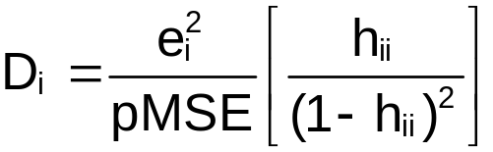
Therefore, only one regression model needs to be fit. From examining the above formula, note how D_{i} can be large (examine e_{i} and h_{ii}).

Guideline for determining influential observations:
- D_{i}>F(0.50, p, n-p)

Influence on the regression coefficients - DFBETAS

Measures the influence of the i^{th} observation on each estimated regression coefficient, b_{k}.

Let
b_{k(i)} be the estimate of β_{k} with the i^{th} observation removed from the data set, and

c_{kk} be the k^{th} diagonal element of (X′X)⁻¹ (remember that X is a n×p matrix)

Then
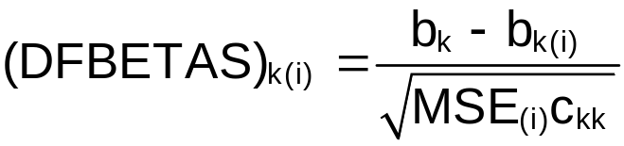 for k=1,…,p-1
Notes:
- Notice that a DFBETAS is calculated for each β_{k} and each observation.
- Remember that  from Chapter 5 and 6. Thus, the variance of  is σ²c_{kk}. In this case, σ² is estimated by MSE_{(i)}. Therefore, the denominator serves as a standardizing measure.

Guideline for determining influential observations:
- |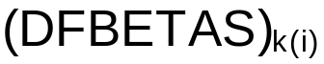|>1 for “small to medium” sized data sets
- ||>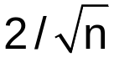 for large data sets

Influence on inferences

Examine the inferences from the sample regression model with and without the observation(s) of concerned. If inferences are unchanged, remedial action is not necessary. If inferences are changed, remedial action is necessary.

Some final comments – p. 406 of KNN

READ! See discussion on “masking” effect.

Example: HS and College GPA data set with extra observation (HS_GPA_ch10.R)

Suppose we look at the data set with the extra observation of (HS GPA, College GPA) = (X, Y) = (4.35, 1.5) added.

> dffits.i<-dffits(model = mod.fit)
> dffits.i[abs(dffits.i)>1]
21
-3.348858

> n<-length(mod.fit$residuals)
> p<-length(mod.fit$coefficients)
> dffits.i[abs(dffits.i)>2*sqrt(p/n)]
21
-3.348858

> cook.i<-cooks.distance(model = mod.fit)
> cook.i[cook.i>qf(p=0.5,df1=p, df2=mod.fit$df.residual)]
21
1.658858

> #Be careful - dfbeta() (without the "s") finds
something a little different
> dfbeta.all<-dfbetas(model = mod.fit)
> dfbeta.all[abs(dfbeta.all[,2])>1,2] #Do not need to
look at beta0, only beta1
[1] -2.911974

> dfbeta.all[abs(dfbeta.all[,2])>2/sqrt(n),2]
18 21
0.4408765 -2.9119744

> round(dfbeta.all,2)
(Intercept) HS.GPA
1 -0.01 0.08
2 0.00 0.00
3 0.06 0.01
4 -0.10 0.07
5 0.00 0.00
6 -0.25 0.34
7 -0.09 0.19
8 0.09 -0.04
9 0.04 0.01
10 0.07 -0.06
11 -0.08 0.04
12 0.02 -0.03
13 0.12 -0.09
14 -0.05 0.08
15 0.05 -0.04
16 -0.31 0.26
17 -0.08 0.04
18 -0.31 0.44
19 -0.02 0.01
20 -0.22 0.16
21 2.17 -2.91

Again, the extra observation added is found by these measures to be potentially influential. One should now examine the model with and without the observation.

Previously without the observation, b₀ = 0.70758 and b₁ = 0.69966. With the observation, b₀ = 1.1203 and b₁ = 0.5037. Thus, we see a change of (0.69966 – 0.5037)/0.69966 = 28% for b₁. While the direction of the relationship has not changed, there is a considerable amount of change in strength. This corresponds to what the DFBETAS found.

With respect to the 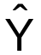 value for X = 4.35, we obtain 3.751092 when using the data set without the extra observation and 3.311581 with the observation. Thus, we see a change of (3.751092 – 3.311581)/ 3.751092 = 11.72%. With respect to percentages, this is possibly not a “large” change. Although based upon our understanding of GPAs, we may think of this more as an important change.

What should you do now? Below are possibilities.
- Find a new predictor variable
- Remove it? NEED justification beyond it being influential.
- Use a different estimation method than least squares which is not as sensitive (Chapter 11)
- Leave it? Include in the model’s interpretation that this observation exists

Of course, it is important to make sure the observation’s data values are correct too.

Example: NBA guard data (nba_ch10.R)

Often when there are a large number of observations, examining graphical summaries of these influence measures can be helpful.

> #DFFITS vs. observation number
> plot(x = 1:n, y = dffits.i, xlab = "Observation
number", ylab = "DFFITS", main = "DFFITS vs.
observation number", panel.first = grid(col =
"gray", lty = "dotted"), ylim = c(min(-1, -
2*sqrt(p/n), min(dffits.i)), max(1, 2*sqrt(p/n),
max(dffits.i))))
> abline(h = 0, col = "darkgreen")
> abline(h = c(-2*sqrt(p/n), 2*sqrt(p/n)), col = "red",
lwd = 2)
> abline(h = c(-1,1), col = "darkred", lwd = 2)
> identify(x = 1:n, y = dffits.i)
[1] 7 21 37 52 53 72 73 104
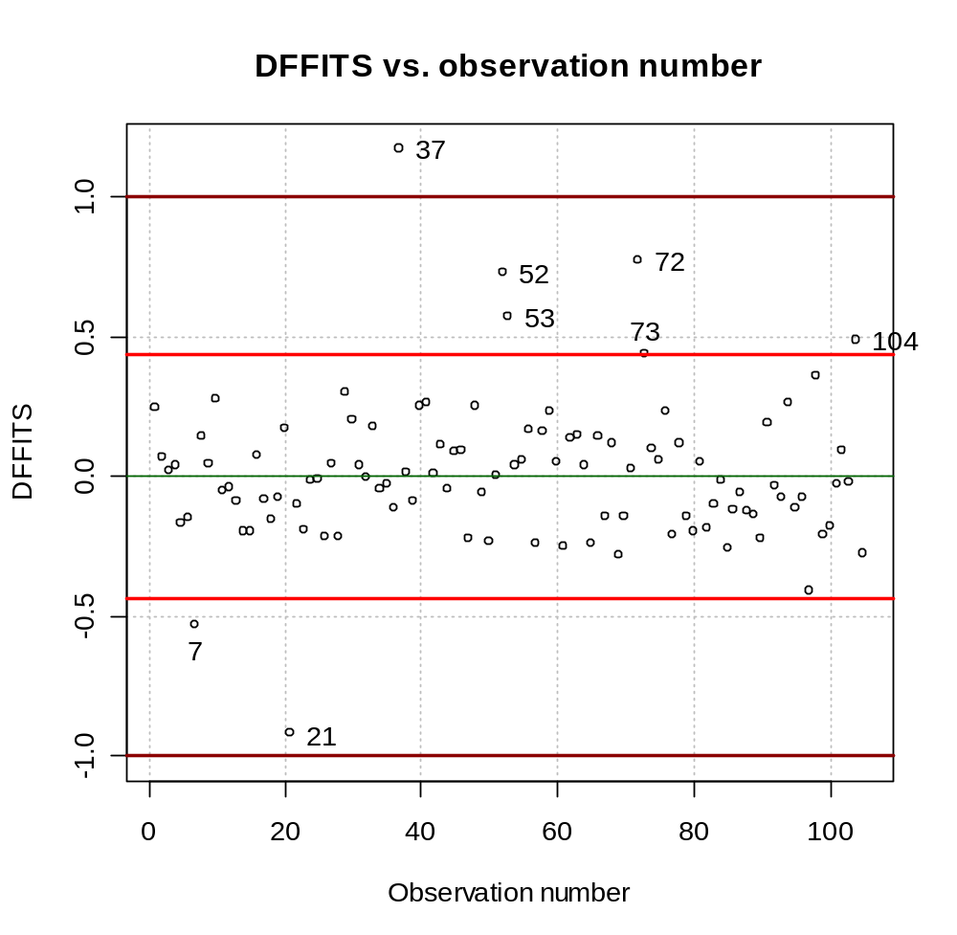

> #Cook's distance vs. observation number
> plot(x = 1:n, y = cook.i, xlab = "Observation number",
ylab = "Cook's D", main = "Cook's vs. observation
number", panel.first = grid(col = "gray", lty =
"dotted"), ylim = c(0, qf(p=0.5,df1=p,
df2=mod.fit$df.residual)))
> abline(h = 0, col = "darkgreen")
> abline(h = qf(p=0.5,df1=p, df2=mod.fit$df.residual),
col = "red", lwd = 2)
> identify(x = 1:n, y = cook.i)
numeric(0)
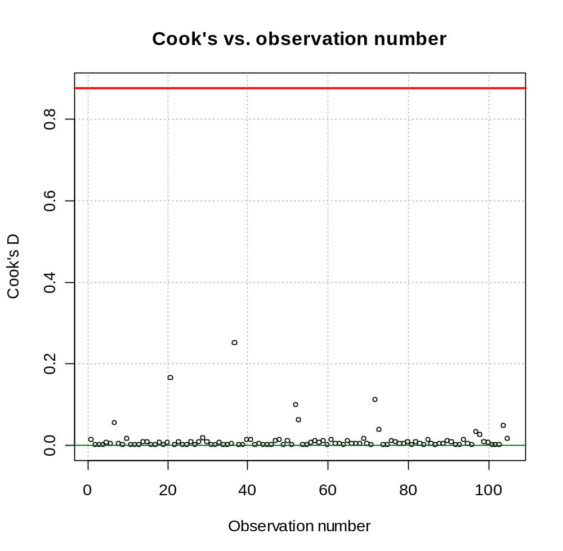

> dfbeta.all<-dfbetas(model = mod.fit)
> pred.var.numb<-length(mod.fit$coefficients)-1

> win.graph(width = 8, height = 6, pointsize = 10)
> par(mfrow = c(2,2))

> for(j in 1:pred.var.numb) {

plot(x = 1:n, y = dfbeta.all[,1+j], xlab =
"Observation number", ylab = "DFBETAS",
main = paste("DFBETAS for variable", j, "vs.
observation number"), panel.first = grid(col =
"gray", lty = "dotted"), ylim = c(min(-1, -
2/sqrt(n), min(dfbeta.all[,1+j])), max(1,
2/sqrt(n), max(dfbeta.all[,1+j]))))
abline(h = 0, col = "darkgreen")
abline(h = c(-2/sqrt(n), 2/sqrt(n)), col = "red", lwd
= 2)
abline(h = c(-1,1), col = "darkred", lwd = 2)
identify(x = 1:n, y = dfbeta.all[,1+j])

}
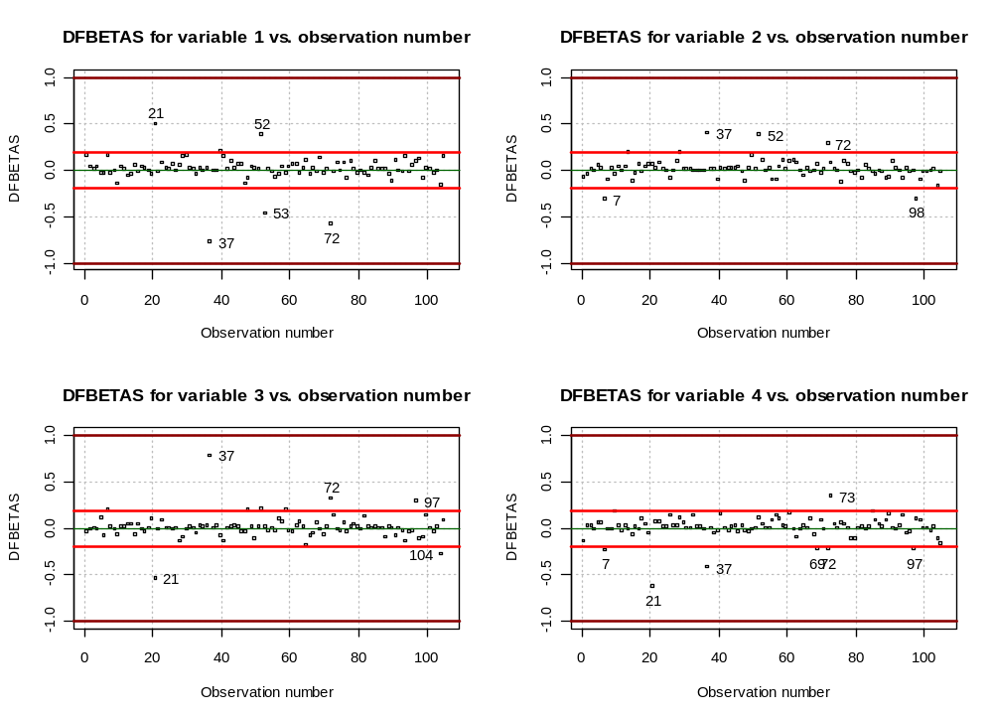

The DFFITS and DFBETAS plots identify some possible influential observations, but the Cook’s Distance plot does not.

“Bubble” plots can be helpful to combine multiple measures on one plot. Below is a plot of the studentized residual vs. with the plotting point’s size proportional to DFFITS.

> #Bubble plot example - note that I need to use the
absolute value function here (size of bubble can not
be negative!)
> par(mfrow = c(1,1))
> symbols(x = mod.fit$fitted.values, y = r.i, circles =
abs(dffits.i), xlab=expression(hat(Y)),
ylab=expression(r[i]),
main = "Studentized residual vs. predicted value
\n Plotting point proportional to
|DFFITS|", inches=0.25,
panel.first=grid(col="gray", lty="dotted"),
ylim = c(min(qt(p = 0.05/(2*n), df =
mod.fit$df.residual), min(r.i)), max(qt(p = 1-
0.05/(2*n), df = mod.fit$df.residual),
max(r.i))))
> abline(h = 0, col = "darkgreen")
> abline(h = c(qt(p = 0.01/2, df = mod.fit$df.residual),
qt(p = 1-0.01/2, df = mod.fit$df.residual)), col
= "red", lwd = 2)
> abline(h = c(qt(p = 0.05/(2*n),df=mod.fit$df.residual),
qt(p = 1-0.05/(2*n), df = mod.fit$df.residual)),
col = "darkred", lwd = 2)
> identify(x = mod.fit$fitted.values, y = r.i)
[1] 21 37 52 53 72

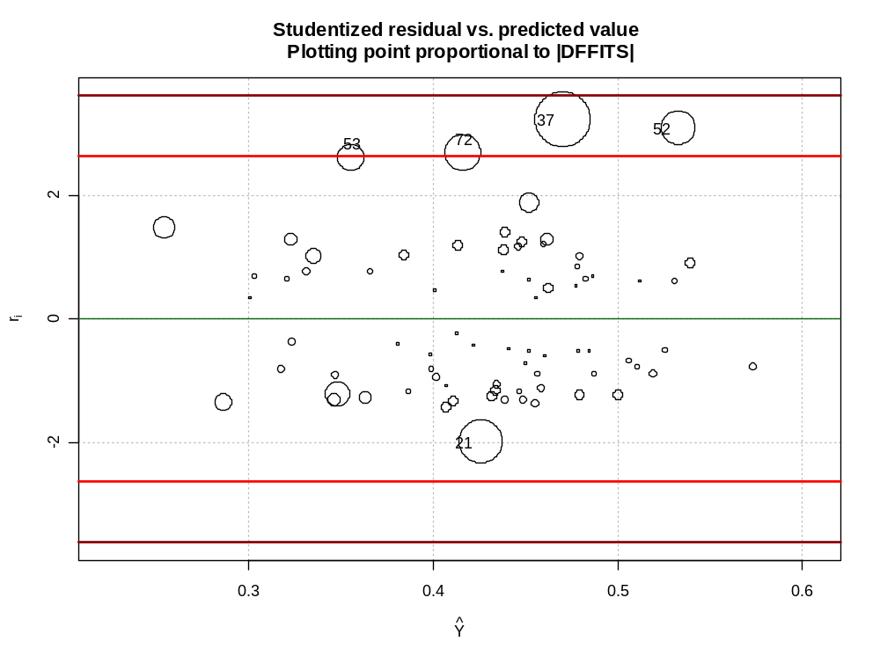

The plot() function can be used with an object of class lm to produce some of these plots shown in Chapter 10 with this data. Investigate these plots on your own by invoking plot(mod.fit, which=1:6). There are 6 possible plots and the which option specifies the plots you want to see.

10.5 Multicollinearity diagnostics – variance inflation factor

Section 7.6 discusses informal ways to detect multicollinearity and the results of multicollinearity. This section discusses a more formal measure of multicollinearity – the variance inflation factor (VIF).

(VIF)_{k} = 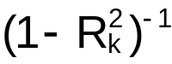 for k=1,…,p-1

where 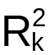 is the coefficient of multiple determination when X_{k} is regressed on the p-2 other X variables in the model.

measures the relationship between X_{k} and the other predictor variables.

If is small (weak relationship) then (VIF)_{k} is small. For example, suppose =0, then (VIF)_{k}=1. If =0.5, then (VIF)_{k}=2.

If is large (strong relationship) then (VIF)_{k} is large. For example, suppose =0.9, then (VIF)_{k}=10. If =0.99, then (VIF)_{k}=100.

A large (VIF)_{k} indicates the existence of multicollinearity.

(VIF)_{k}>10

Note that large VIF’s for interactions, quadratic terms, … are to be expected. Why?

Example: NBA guard data (nba_ch10.R)

The vif() function in the car package can find the VIF values.

> library(car)
> vif(mod.fit)
MPG height FGP age
1.157843 1.019022 1.148573 1.042805

Since the VIFs are close to 1, there is no evidence of multicolinearity.

To show where the VIF for MPG comes from, the following R code is run.

> mod.fit.MPG<-lm(formula = MPG ~ height + FGP + age,
data = nba)
> sum.fit.MPG<-summary(mod.fit.MPG)
> 1/(1-sum.fit.MPG$r.squared)
[1] 1.157843

(VIF)_{MPG}=

Example: multicollinearity.R – From Chapter 7

Data was generated so that the predictor variables, X₁ and X₂, are highly correlated. At the end of the program, I ran the following:

> mod.fit12<-lm(formula = Y ~ X1 + X2, data = set1)
> vif(mod.fit12)
X1 X2
25064.03 25064.03

Since the VIFs are large, there is evidence of multicolinearity.

10.6 Surgical unit example

Read!

Example: NBA guard data (nba_end_of_ch10.R)

Consider the model: E(PPM) = β₀ + β₁MPG + β₂Height + β₃FGP + β₄Age

- Examine the added variable regression plots for each predictor variable.
  - MPG: At least a linear relationship, possibly a quadratic relationship
  - Height: A linear relationship
  - FGP: A linear relationship
  - Age: Possibly a linear relationship

- Keeping MPG, Height, FGP, and Age in the model, quadratic and pairwise interaction terms are examined.

One could just limit the quadratic terms to MPG due to the added variable plots (or include an examination of all of them here). I will just look at MPG² and also age² due to a hypothesis that I had earlier about a quadratic relationship. All interactions should be examined.

Below is forward selection using t-tests as the criteria for whether or not to add a term to the model.

> #######################################################
> # Step #2

> test.var<-function(Ho, Ha, data) {
Ho.mod<-lm(formula = Ho, data = data)
Ha.mod<-lm(formula = Ha, data = data)
anova.fit<-anova(Ho.mod, Ha.mod)
round(anova.fit$"Pr(>F)"[2], 5)
}

>#########################################################
> # Forward

> Ho.model<-PPM ~ MPG + height + FGP + age
#NOTE: Had difficulty combining the Ha model extra
variables with Ho.model
> MPG.height<-test.var(Ho = Ho.model, Ha = PPM ~ MPG +
height + FGP + age + MPG:height, data = nba)
> MPG.FGP <-test.var(Ho = Ho.model, Ha = PPM ~ MPG +
height + FGP + age + MPG:FGP , data = nba)
> MPG.age <-test.var(Ho = Ho.model, Ha = PPM ~ MPG +
height + FGP + age + MPG:age , data = nba)
> height.FGP<-test.var(Ho = Ho.model, Ha = PPM ~ MPG +
height + FGP + age + height:FGP, data = nba)
> height.age<-test.var(Ho = Ho.model, Ha = PPM ~ MPG +
height + FGP + age + height:age, data = nba)
> FGP.age <-test.var(Ho = Ho.model, Ha = PPM ~ MPG +
height + FGP + age + FGP:age, data = nba)
> MPG.sq <-test.var(Ho = Ho.model, Ha = PPM ~ MPG +
height + FGP + age + I(MPG^2), data = nba)
> age.sq <-test.var(Ho = Ho.model, Ha = PPM ~ MPG +
height + FGP + age + I(age^2), data = nba)
> data.frame(MPG.height, MPG.FGP, MPG.age, height.FGP,
height.age, FGP.age, MPG.sq, age.sq)
MPG.height MPG.FGP MPG.age height.FGP height.age FGP.age MPG.sq
1 0.66575 0.69627 3e-05 0.08826 0.81072 0.7059 0

age.sq
0.30965

> #ADDED MPG^2
> Ho.model<-PPM ~ MPG + height + FGP + age + I(MPG^2)
> MPG.height<-test.var(Ho = Ho.model, Ha = PPM ~ MPG +
height + FGP + age + I(MPG^2) + MPG:height, data = nba)
> MPG.FGP <-test.var(Ho = Ho.model, Ha = PPM ~ MPG +
height + FGP + age + I(MPG^2) + MPG:FGP , data = nba)
> MPG.age <-test.var(Ho = Ho.model, Ha = PPM ~ MPG +
height + FGP + age + I(MPG^2) + MPG:age , data = nba)
> height.FGP<-test.var(Ho = Ho.model, Ha = PPM ~ MPG +
height + FGP + age + I(MPG^2) + height:FGP, data = nba)
> height.age<-test.var(Ho = Ho.model, Ha = PPM ~ MPG +
height + FGP + age + I(MPG^2) + height:age, data = nba)
> FGP.age <-test.var(Ho = Ho.model, Ha = PPM ~ MPG +
height + FGP + age + I(MPG^2) + FGP:age, data = nba)
> age.sq <-test.var(Ho = Ho.model, Ha = PPM ~ MPG +
height + FGP + age + I(MPG^2) + I(age^2), data = nba)
> data.frame(MPG.height, MPG.FGP, MPG.age, height.FGP,
height.age, FGP.age, age.sq)
MPG.height MPG.FGP MPG.age height.FGP height.age FGP.age age.sq
1 0.54101 0.06785 0.00265 0.15594 0.71377 0.40024 0.18541

> #ADDED MPG:age
> Ho.model<-PPM ~ MPG + height + FGP + age + I(MPG^2) +
MPG:age
> MPG.height<-test.var(Ho = Ho.model, Ha = PPM ~ MPG +
height + FGP + age + I(MPG^2) + MPG:age + MPG:height,
data = nba)
> MPG.FGP <-test.var(Ho = Ho.model, Ha = PPM ~ MPG +
height + FGP + age + I(MPG^2) + MPG:age + MPG:FGP ,
data = nba)
> height.FGP<-test.var(Ho = Ho.model, Ha = PPM ~ MPG +
height + FGP + age + I(MPG^2) + MPG:age + height:FGP,
data = nba)
> height.age<-test.var(Ho = Ho.model, Ha = PPM ~ MPG +
height + FGP + age + I(MPG^2) + MPG:age + height:age,
data = nba)
> FGP.age <-test.var(Ho = Ho.model, Ha = PPM ~ MPG +
height + FGP + age + I(MPG^2) + MPG:age + FGP:age, data
= nba)
> age.sq <-test.var(Ho = Ho.model, Ha = PPM ~ MPG +
height + FGP + age + I(MPG^2) + MPG:age + I(age^2), data
= nba)
> data.frame(MPG.height, MPG.FGP, height.FGP, height.age,
FGP.age, age.sq)
MPG.height MPG.FGP height.FGP height.age FGP.age age.sq
1 0.72082 0.03834 0.33561 0.62054 0.21691 0.42181

> #ADDED MPG:FGP - marginally significant (maybe should not
add)
> Ho.model<-PPM ~ MPG + height + FGP + age + I(MPG^2) +
MPG:age + MPG:FGP
> MPG.height<-test.var(Ho = Ho.model, Ha = PPM ~ MPG +
height + FGP + age + I(MPG^2) + MPG:age + MPG:FGP +
MPG:height, data = nba)
> height.FGP<-test.var(Ho = Ho.model, Ha = PPM ~ MPG +
height + FGP + age + I(MPG^2) + MPG:age + MPG:FGP +
height:FGP, data = nba)
> height.age<-test.var(Ho = Ho.model, Ha = PPM ~ MPG +
height + FGP + age + I(MPG^2) + MPG:age + MPG:FGP +
height:age, data = nba)
> FGP.age <-test.var(Ho = Ho.model, Ha = PPM ~ MPG +
height + FGP + age + I(MPG^2) + MPG:age + MPG:FGP +
FGP:age, data = nba)
> age.sq <-test.var(Ho = Ho.model, Ha = PPM ~ MPG +
height + FGP + age + I(MPG^2) + MPG:age + MPG:FGP +
I(age^2), data = nba)
> data.frame(MPG.height, height.FGP, height.age, FGP.age,
age.sq)
MPG.height height.FGP height.age FGP.age age.sq
1 0.58201 0.22574 0.89787 0.38076 0.20444

Could also examine cubic and/or three-way interactions.

Let’s examine the models a little here.

> #Examine models
> mod.fit1<-lm(formula = PPM ~ MPG + height + FGP + age +
I(MPG^2) + MPG:age, data = nba)
> summary(mod.fit1)

Call:
lm(formula = PPM ~ MPG + height + FGP + age + I(MPG^2) + MPG:age, data = nba)

Residuals:
Min 1Q Median 3Q Max
-0.176248 -0.060386 -0.006655 0.059309 0.186663

Coefficients:
Estimate Std. Error t value Pr(>|t|)
(Intercept) -2.654e-01 2.847e-01 -0.932 0.353570
MPG -3.940e-02 7.657e-03 -5.146 1.37e-06 ***
height 4.821e-03 1.189e-03 4.056 0.000100 ***
FGP 1.096e-02 2.048e-03 5.350 5.76e-07 ***
age -2.277e-02 6.629e-03 -3.436 0.000869 ***
I(MPG^2) 3.952e-04 9.821e-05 4.024 0.000113 ***
MPG:age 8.752e-04 2.838e-04 3.084 0.002651 **
---
Signif. codes: 0 '***' 0.001 '**' 0.01 '*' 0.05 '.' 0.1 ' ' 1

Residual standard error: 0.08447 on 98 degrees of freedom
Multiple R-Squared: 0.4993, Adjusted R-squared: 0.4687
F-statistic: 16.29 on 6 and 98 DF, p-value: 6.285e-13

> mod.fit2<-lm(formula = PPM ~ MPG + height + FGP + age +
I(MPG^2) + MPG:age + MPG:FGP, data = nba)
> summary(mod.fit2)

Call:
lm(formula = PPM ~ MPG + height + FGP + age + I(MPG^2) +
MPG:age + MPG:FGP, data = nba)

Residuals:
Min 1Q Median 3Q Max
-0.177675 -0.061218 -0.006629 0.049225 0.209383

Coefficients:
Estimate Std. Error t value Pr(>|t|)
(Intercept) -6.329e-01 3.301e-01 -1.917 0.058172 .
MPG -2.274e-02 1.094e-02 -2.079 0.040286 *
height 5.013e-03 1.172e-03 4.277 4.44e-05 ***
FGP 1.924e-02 4.428e-03 4.344 3.44e-05 ***
age -2.330e-02 6.521e-03 -3.572 0.000553 ***
I(MPG^2) 4.431e-04 9.919e-05 4.467 2.15e-05 ***
MPG:age 9.057e-04 2.793e-04 3.242 0.001626 **
MPG:FGP -4.381e-04 2.087e-04 -2.100 0.038345 *
---
Signif. codes: 0 '***' 0.001 '**' 0.01 '*' 0.05 '.' 0.1 ' ' 1

Residual standard error: 0.08304 on 97 degrees of freedom
Multiple R-Squared: 0.5211, Adjusted R-squared: 0.4865
F-statistic: 15.08 on 7 and 97 DF, p-value: 3.438e-13

Should MPG∗FGP be included?

Notes:
  - Note that this last step is sort of a “backward elimination” step to make sure everything should stay in the model.
  - Notice that the MPG∗Age interaction would not have been found if Age was not considered after using the regression procedures discussed in Chapter 9 (age had a p-value of 0.0795 in the model including MPG, Height, FGP, and Age).
  - Remember that we can not look at the t-test for MPG and age only due to the interactions and quadratic terms present (for model #1). If Age or MPG were nonsignificant, they still would be left in the model.

Here’s how the step function and the AIC can be used:

> #Try using the step() function and AIC
> mod.fit.for<-lm(formula = PPM ~ MPG + height + FGP + age,
data = nba)
> step.both<-step(object = mod.fit.for, direction = "both",
scope=list(lower = PPM ~ MPG + height + FGP + age,
upper = PPM ~ MPG + height + FGP + age + MPG:height
+ MPG:FGP + MPG:age + height:FGP + height:age
+ FGP:age + I(MPG^2) + I(age^2)), k = 2)

Start: AIC= -481.84
PPM ~ MPG + height + FGP + age
Df Sum of Sq RSS AIC
+ I(MPG^2) 1 0.20 0.77 -504.49
+ MPG:age 1 0.16 0.81 -498.16
+ height:FGP 1 0.03 0.94 -482.93
<none> 0.97 -481.84
+ I(age^2) 1 0.01 0.96 -480.94
+ MPG:height 1 0.0018365 0.97 -480.03
+ MPG:FGP 1 0.0014998 0.97 -480.00
+ FGP:age 1 0.0014017 0.97 -479.99
+ height:age 1 0.0005648 0.97 -479.90

Step: AIC= -504.49
PPM ~ MPG + height + FGP + age + I(MPG^2)
Df Sum of Sq RSS AIC
+ MPG:age 1 0.07 0.70 -512.22
+ MPG:FGP 1 0.03 0.74 -506.08
+ height:FGP 1 0.02 0.75 -504.66
<none> 0.77 -504.49
+ I(age^2) 1 0.01 0.75 -504.38
+ FGP:age 1 0.01 0.76 -503.25
+ MPG:height 1 0.002935 0.76 -502.89
+ height:age 1 0.001058 0.77 -502.64
- I(MPG^2) 1 0.20 0.97 -481.84

Step: AIC= -512.22
PPM ~ MPG + height + FGP + age + I(MPG^2) + MPG:age
Df Sum of Sq RSS AIC
+ MPG:FGP 1 0.03 0.67 -514.89
<none> 0.70 -512.22
+ FGP:age 1 0.01 0.69 -511.88
+ height:FGP 1 0.01 0.69 -511.23
+ I(age^2) 1 0.0046605 0.69 -510.92
+ height:age 1 0.0017740 0.70 -510.49
+ MPG:height 1 0.0009249 0.70 -510.36
- MPG:age 1 0.07 0.77 -504.49
- I(MPG^2) 1 0.12 0.81 -498.16

Step: AIC= -514.89
PPM ~ MPG + height + FGP + age + I(MPG^2) + MPG:age + MPG:FGP
Df Sum of Sq RSS AIC
<none> 0.67 -514.89
+ I(age^2) 1 0.01 0.66 -514.66
+ height:FGP 1 0.01 0.66 -514.50
+ FGP:age 1 0.01 0.66 -513.73
+ MPG:height 1 0.0021189 0.67 -513.22
+ height:age 1 0.0001154 0.67 -512.91
- MPG:FGP 1 0.03 0.70 -512.22
- MPG:age 1 0.07 0.74 -506.08
- I(MPG^2) 1 0.14 0.81 -497.25

> step.both$anova
Step Df Deviance Resid. Df Resid. Dev AIC
1 NA NA 100 0.9702591 -481.8360
2 + I(MPG^2) -1 0.20306089 99 0.7671982 -504.4919
3 + MPG:age -1 0.06788554 98 0.6993127 -512.2199
4 + MPG:FGP -1 0.03040435 97 0.6689083 -514.8872

While the AIC found MPG∗FGP to improve the model, it is still questionable whether or not one would want to include a term with a t-test p-value of 0.0383. There is justification for including or not including it. I recommend examining the diagnostic measures to help make a final decision.

- Examine diagnostic measures

The examine.mod.multiple.final.R function (based on examine.mod.multiple.R from Chapter 6) has been modified to help with this examination process. Here are some notes about it:

- Pred.var.numb is no longer in the function. Instead, it has been replaced with first.order or p. Note that first.order is a REQUIRED value to pass into the function and represents the number of terms excluding interactions, quadratic effects, … . For example, this would be 4 for the NBA example here (MPG, height, FGP, and age). These terms need to be the FIRST variables specified in the formula statement when fitting the model.
- There are a lot of plots created. You may want to modify the function to avoid some plots being created every time - like the box and dot plots for the response and predictor variables.

> save.it<-examine.mod.multiple.final(mod.fit.obj =
mod.fit1, first.order = 4, const.var.test =
TRUE, boxcox.find = TRUE)

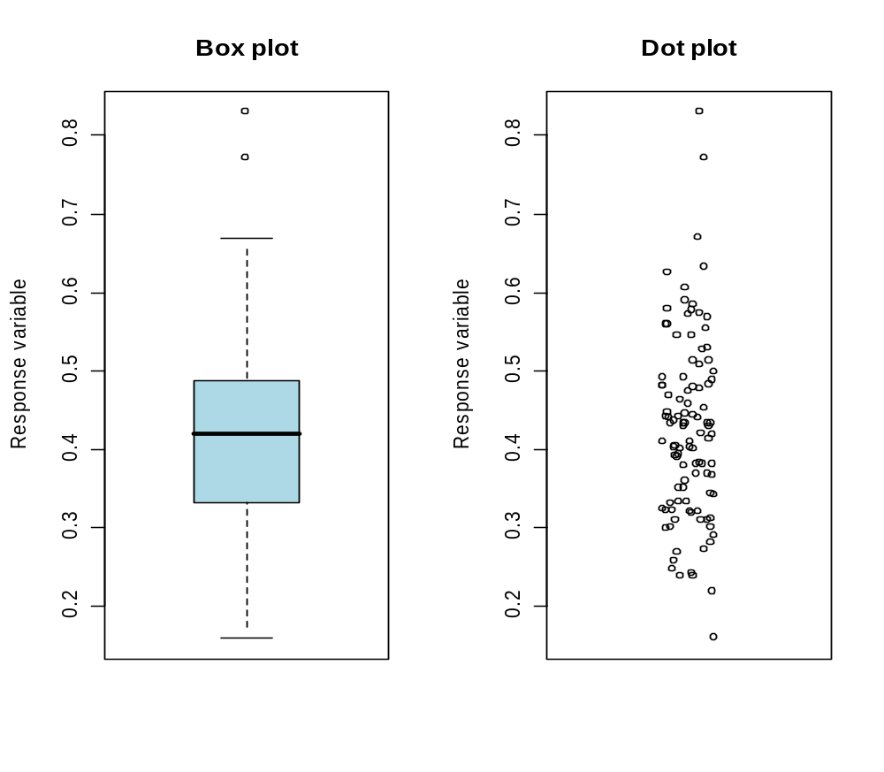
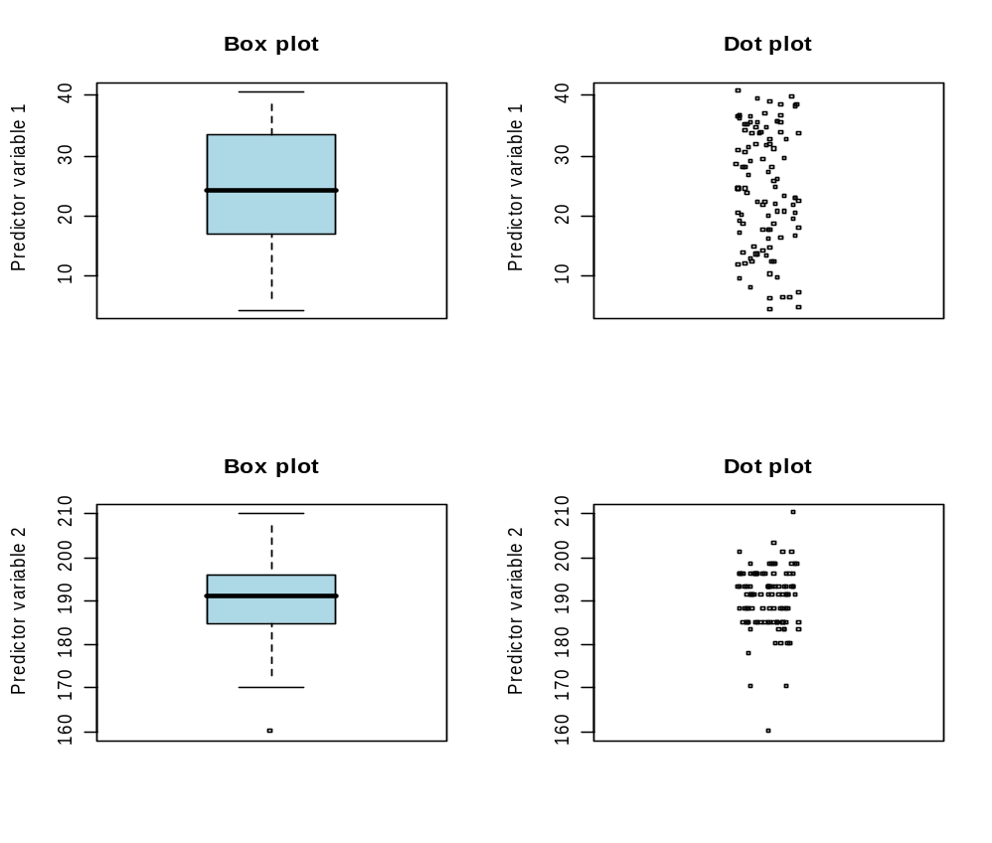

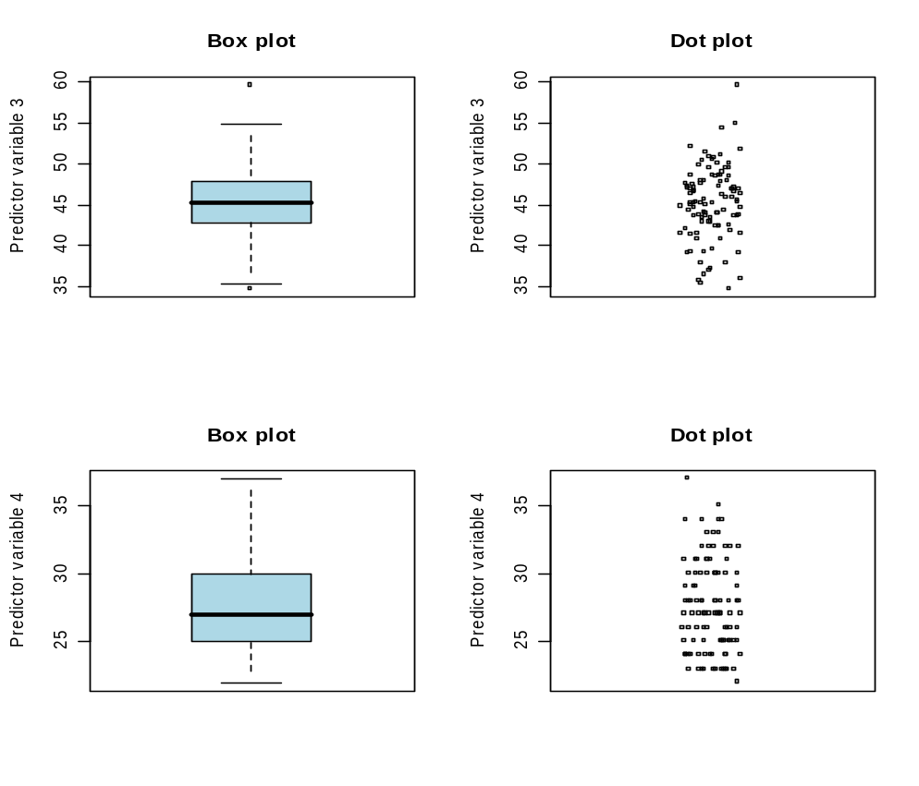
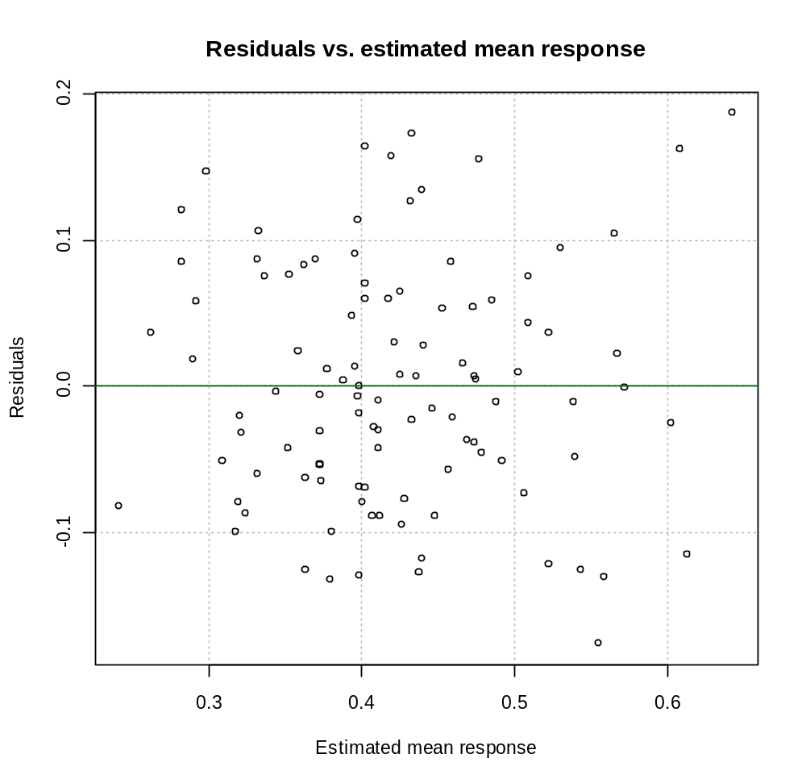

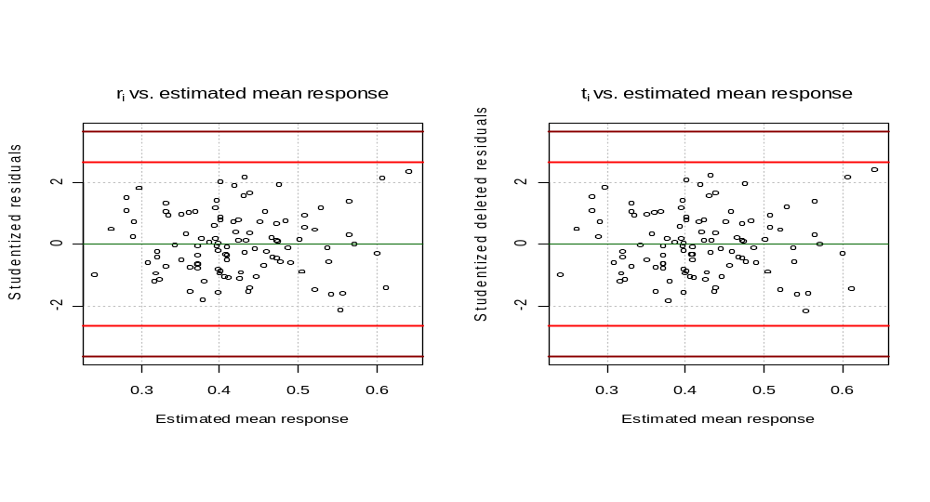
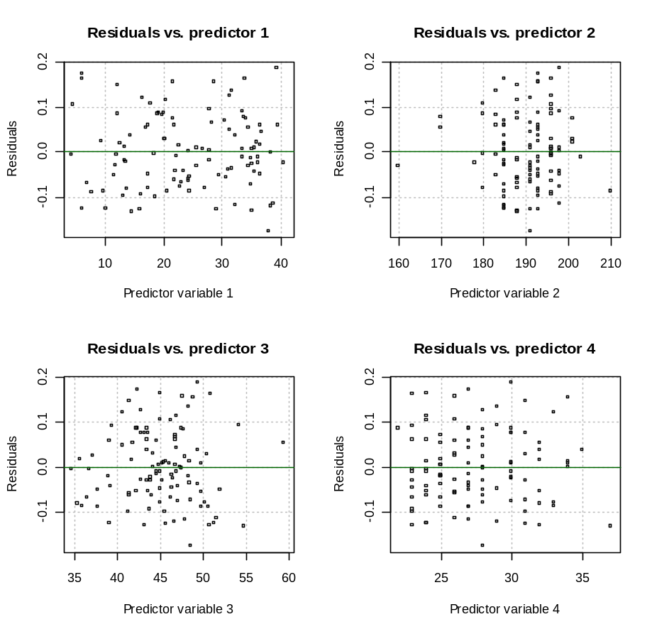
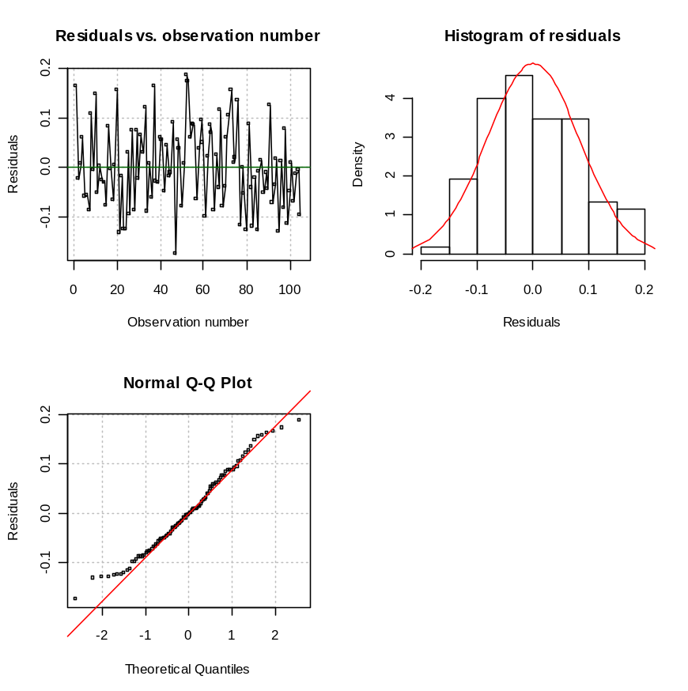

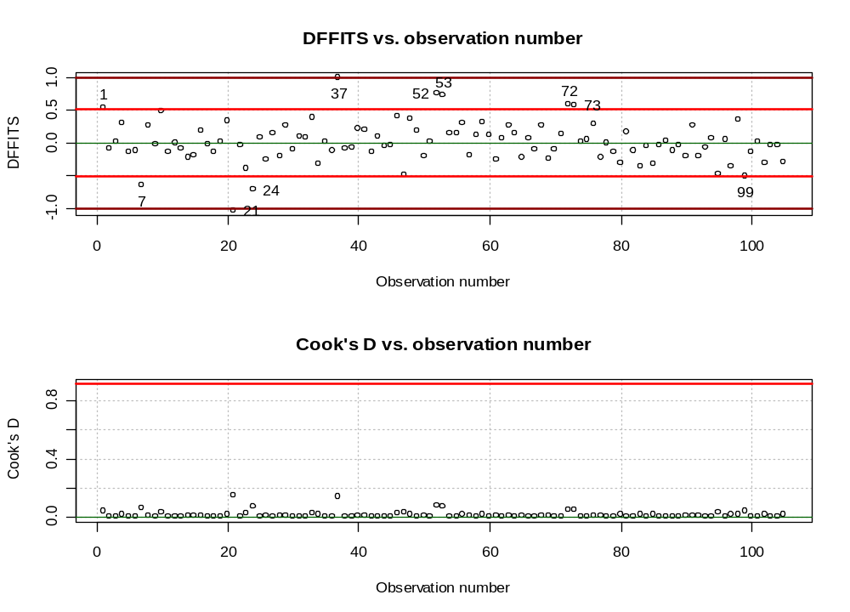
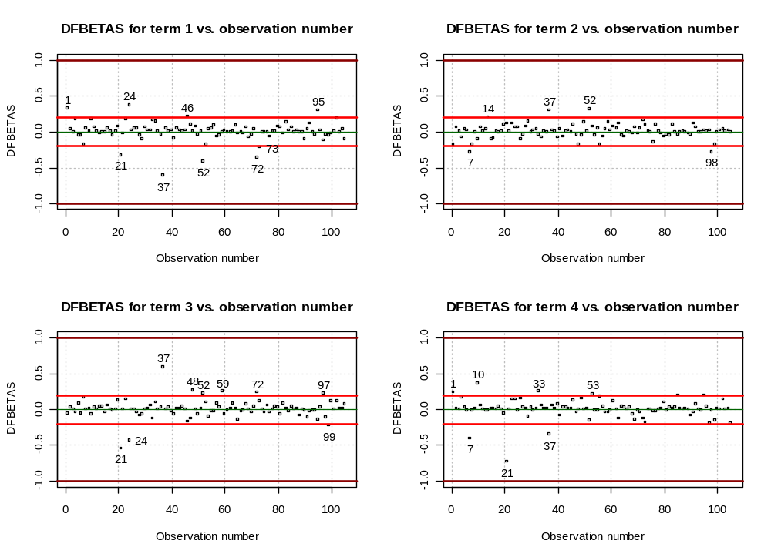
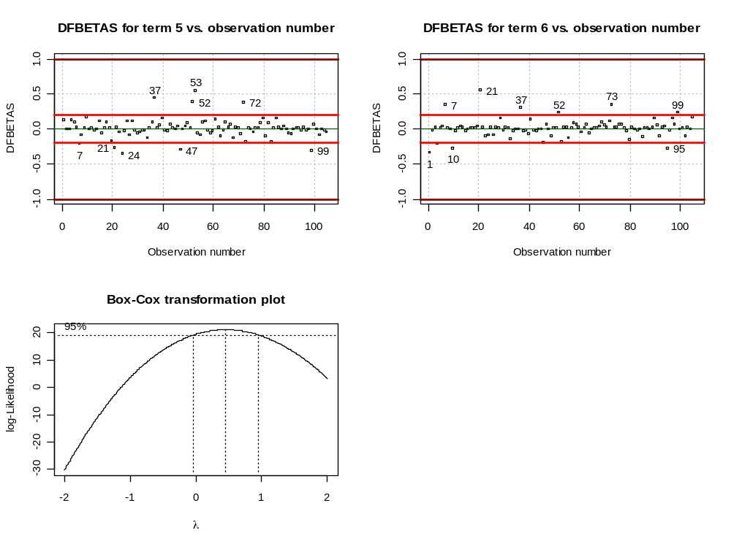

Comments:
    - e_{i} vs. each predictor variable: There appears to be a random scattering of points in each plot, so it appears the predictor variables are specified correctly in the model.
    - e_{i} vs. : Since the variability of the residuals does not appear to change, there does not seem to be any problems with the constant variance assumption. Regarding the hypothesis tests for constant variance, we obtain:

> save.it$levene
[,1] [,2] [,3]
[1,] 1 1.4595 0.2297708
[2,] 2 0.1472 0.7019944
[3,] 3 0.5492 0.4603125
[4,] 4 0.4137 0.5215204
> save.it$bp

Breusch-Pagan test

data: mod.fit.obj
BP = 9.7132, df = 6, p-value = 0.1373

indicating the same results as in the plot. However, the Box-Cox transformation procedure

> save.it$lambda.hat
[1] 0.45

indicates marginal evidence (see the confidence interval) that a transformation may be needed. I did try a square root transformation and there did not appear to be any benefits from it.

    - e_{i} vs. order of observation plot: This would be used to check for dependence among the ε_{i}. Since the observations were put in alphabetical order here, the order of the observation does not give meaningful information.
    - Check for outliers with a plot of r_{i} vs. and t_{i} vs. . These diagnostic measures could also be plotted versus observation number, but it can be helpful to see patterns with the estimated mean response. No observations are past their boundary lines. Therefore, there are no outlying Y values detected using studenized and studentized deleted residuals.
    - Check for influential observations using a number of plots involving DFFITS, Cook’s D and DFBETAS. Some of these measures have different criteria for small/medium or large sized data sets. I think this data set is closer to “medium” in size, but it is still useful to look at the large boundary lines as well.
        - DFFITS – Some observations are of concern. Below are all of them highlighted on the plot. #21 and #37 are outside of the small/medium sized data set boundary lines.

> nba[c(1,7,21,24,37,52,53,72,73,99),]
last.name first.initial games PPM MPG height FTP FGP age
1 Abdul-Rauf M. 80 0.5668 33.8750 185 93.5 45.0 24
7 Bagley J. 10 0.2371 9.7000 210 83.3 36.0 33
21 Cheeks M. 35 0.2471 14.5714 188 88.9 54.8 37
24 Crotty J. 39 0.4173 6.2308 185 68.4 51.4 24
37 Green S. 13 0.7704 6.2308 196 75.0 50.9 23
52 Jordan M. 78 0.8291 39.3205 198 83.7 49.5 30
53 Kimble B. 9 0.6055 6.1111 193 37.5 42.4 27
72 Phills B. 31 0.6691 4.4839 196 60.0 46.3 24
73 Pierce R. 77 0.6318 28.8052 193 88.9 48.9 34
99 West D. 80 0.4974 38.8000 198 84.1 51.7 26

        - Cook’s D – No observations are of concern
        - DFBETAS – Some observations are of concern using the “large” data set guidelines.

> nba[c(1,7,10,14,21,24,33,37,46,47,48,52,53,59,72,73,95,97,98,99),]
last.name first.initial games PPM MPG height FTP FGP age
1 Abdul-Rauf M. 80 0.5668 33.8750 185 93.5 45.0 24
7 Bagley J. 10 0.2371 9.7000 210 83.3 36.0 33
10 Battle J. 41 0.4455 12.1220 188 77.8 41.5 31
14 Bogues T. 82 0.2894 34.5488 160 83.3 45.3 28
21 Cheeks M. 35 0.2471 14.5714 188 88.9 54.8 37
24 Crotty J. 39 0.4173 6.2308 185 68.4 51.4 24
33 Floyd S. 53 0.4035 16.3585 191 79.4 40.7 33
37 Green S. 13 0.7704 6.2308 196 75.0 50.9 23
46 Jackson J. 28 0.4866 33.5000 198 73.9 39.5 23
47 Jackson M. 82 0.3788 38.0122 191 80.3 48.6 28
48 Jennings K. 8 0.5059 17.0000 170 77.8 59.5 25
52 Jordan M. 78 0.8291 39.3205 198 83.7 49.5 30
53 Kimble B. 9 0.6055 6.1111 193 37.5 42.4 27
59 Marciulion S. 30 0.6244 27.8667 196 76.1 54.3 29
72 Phills B. 31 0.6691 4.4839 196 60.0 46.3 24
73 Pierce R. 77 0.6318 28.8052 193 88.9 48.9 34
95 Threatt S. 82 0.4280 35.2805 188 82.3 50.8 32
97 Walker D. 37 0.1593 13.8108 193 46.2 35.4 32
98 Webb S. 69 0.4285 33.8406 170 85.1 43.3 30
99 West D. 80 0.4974 38.8000 198 84.1 51.7 26

Using ||>1 as a measure of influence, there does not appear to be any influential observations according to this criterion. In fact, there are no observations close to the borderline.

    - Histogram and QQ-plot of residuals: Perhaps, a little left skewed; I would not say this is a “large” concern. There does not appear to be “strong” evidence against the normality assumption.

The main item that needs to be investigated is the potentially influential observations detected by the DFFITS and somewhat by the DFBETAS. Let’s examine what if #21 or #37 are removed from the data set. NOTE: JUST BECAUSE I AM REMOVING THEM DOES NOT MEAN THERE IS JUSTIFICATION FOR REMOVAL. I AM ONLY DOING THIS TO EXAMINE INFLUENCE ON THE b_{j}’s.

> #What if #21 or #37 were removed from the data set?
> mod.fit1.wo21<-lm(formula = PPM ~ MPG + height + FGP +
age + I(MPG^2) + MPG:age, data = nba[-21,])
> summary(mod.fit1.wo21)$coefficients
Estimate Std. Error t value Pr(>|t|)
(Intercept) -0.3978677068 2.905487e-01 -1.369367 1.740468e-01
MPG -0.0369078799 7.688408e-03 -4.800458 5.745381e-06
height 0.0046957623 1.176727e-03 3.990528 1.280809e-04
FGP 0.0120583297 2.111290e-03 5.711357 1.226675e-07
age -0.0179676116 7.057341e-03 -2.545946 1.247289e-02
I(MPG^2) 0.0004216459 9.811947e-05 4.297270 4.112989e-05
MPG:age 0.0007227815 2.925264e-04 2.470825 1.522474e-02

> round((mod.fit1.wo21$coefficients –
mod.fit1$coefficients)/mod.fit1$coefficients,2)
(Intercept) MPG height FGP age
0.50 -0.06 -0.03 0.10 -0.21

I(MPG^2) MPG:age
0.07 -0.17

> mod.fit1.wo37<-lm(formula = PPM ~ MPG + height + FGP +
age + I(MPG^2) + MPG:age, data = nba[-37,])
> summary(mod.fit1.wo37)$coefficients
Estimate Std. Error t value Pr(>|t|)
(Intercept) -0.2404303899 2.798611e-01 -0.8591062 3.924000e-01
MPG -0.0347629948 7.822265e-03 -4.4441085 2.346004e-05
height 0.0044691542 1.178746e-03 3.7914473 2.602819e-04
FGP 0.0097758776 2.084128e-03 4.6906318 8.921558e-06
age -0.0204521938 6.598283e-03 -3.0996235 2.536075e-03
I(MPG^2) 0.0003536885 9.835883e-05 3.5959003 5.105946e-04
MPG:age 0.0007940138 2.811991e-04 2.8236714 5.762152e-03

> round((mod.fit1.wo37$coefficients –
mod.fit1$coefficients)/mod.fit1$coefficients,2)
(Intercept) MPG height FGP age
-0.09 -0.12 -0.07 -0.11 -0.10
I(MPG^2) MPG:age
-0.11 -0.09

We do see some change in the estimated coefficients. Notice that all terms still have significant t-tests and the direction of the association (+ or – on the b_{j}’s) does not change. Given this information, this is enough for me to use this model. It may be of interest to examine some of the other observations with moderately large DFBETAS as well.

Here is a discussion about some of these players found to be potentially influential.

- #7 Bagley – VERY tall for a guard at 6’ 10” (notice that the DFBETA for Height is one of the largest for this player); Only played in 10 games (there are 82 games in a NBA season)
- #14 Bogues – VERY short for a guard at 5’ 3”
- #21 Cheeks – Old for an NBA player (notice that the DFBETA for age is one of the largest for this player); Only played in 35 games
- #37 Green – Only played in 13 games; Scores a lot (Jordan is the highest at PPM=0.83), but only plays 6.2 minutes per game
- #48 Jennings – Only played in 8 games
- See the rest on your own.

Overall, many of these players have something in common – they did not play in a large number of games relative to the 82 game season. What happens if we limit the population to NBA guards that appear in at least 41 games (half the season)?

- Of the 105 players in the data set, 16 of them did not play in at least half the games.
- There are a number of marginally significant variables for this smaller data set, I obtain a model with MPG, height, FGP, FTP, MPG², MPG∗FTP, and MPG∗FGP (although other models are justifiable as well).
- Michael Jordan is the only outlier and sometimes diagnostic measures show it may be influential. I could not find a good way to handle Jordan so this may be a situation where one would just need to accept this provided one thinks this analysis route (limiting population of interest) is best to do.

What if the MPG∗FGP interaction was added and the full data was used?

Mostly everything stays the same. The main differences are some diagnostic measures show a few observations becoming more influential. For example,

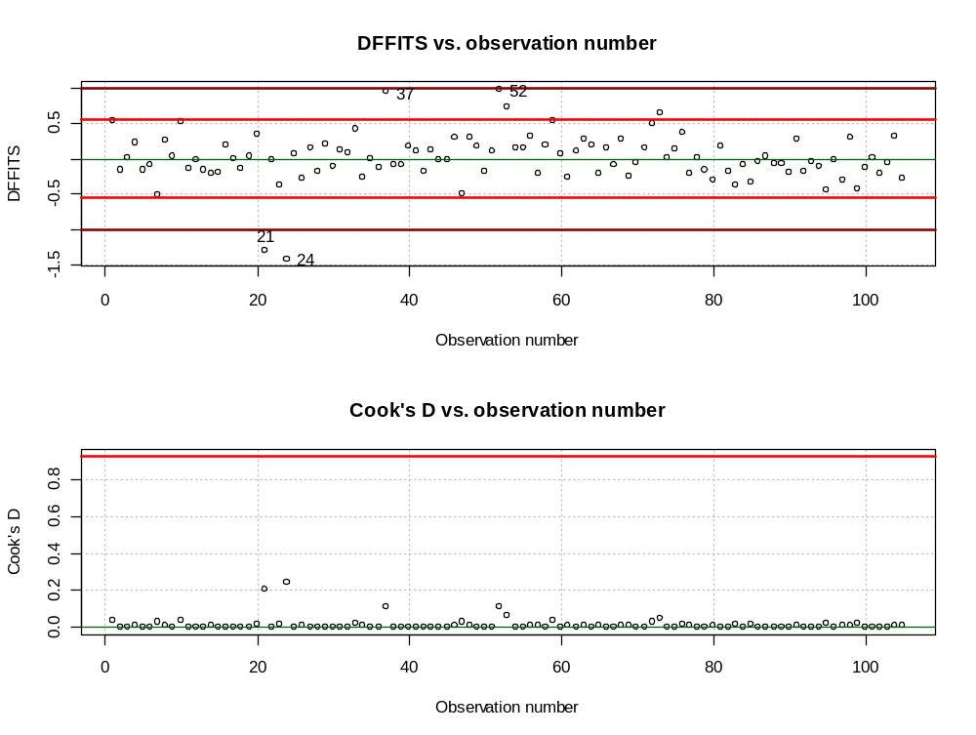
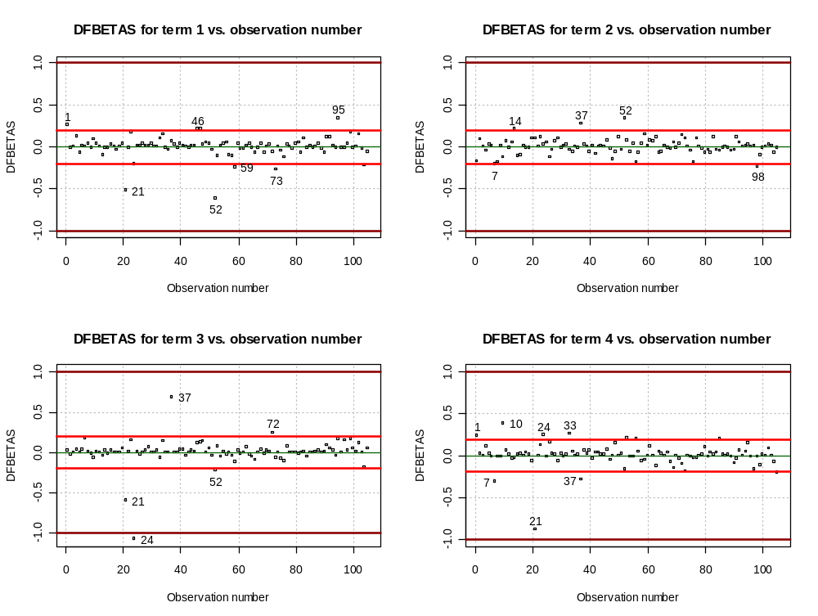
Observations #21 and #24 are

> nba[c(21,24),]
last.name first.initial games PPM MPG height FTP FGP age
21 Cheeks M. 35 0.2471 14.5714 188 88.9 54.8 37
24 Crotty J. 39 0.4173 6.2308 185 68.4 51.4 24

Just to quickly see the effect of this observations excluded from the data set (this does not mean you should remove them!), I refit the model without them.

> mod.fit.temp<-lm(formula = PPM ~ MPG + height + FGP +
age + I(MPG^2) + MPG:age + MPG:FGP,
data = nba[-c(21,24),])
> summary(mod.fit.temp)$coefficients
Estimate Std. Error t value Pr(>|t|)
(Intercept) -1.0078704546 0.3298641245 -3.055411 2.917338e-03
MPG -0.0137220678 0.0106699196 -1.286052 2.015507e-01
height 0.0048324428 0.0011077543 4.362378 3.266362e-05
FGP 0.0275633982 0.0047499077 5.802933 8.555533e-08
age -0.0184096471 0.0066330443 -2.775445 6.639175e-03
I(MPG^2) 0.0005737510 0.0001001627 5.728190 1.187864e-07
MPG:age 0.0007608212 0.0002748924 2.767705 6.786608e-03
MPG:FGP -0.0007144539 0.0002114364 -3.379049 1.056286e-03

> round((mod.fit.temp$coefficients –
mod.fit2$coefficients)/mod.fit2$coefficients,2)
(Intercept) MPG height FGP age
0.59 -0.40 -0.04 0.43 -0.21 I(MPG^2) MPG:age MPG:FGP
0.29 -0.16 0.63

Previously, the b_{MPG∗FGP} = -0.0004381 with a t-test p-value of 0.038345. Without #21 and #24, the relative change is

> (-0.0007145+0.0004381)/(-0.0004381)
[1] 0.6309062

While the direction of association stays the same and the t-test is still significant, the change in the b_{MPG∗FGP} is somewhat worrisome. If possible, I would use a different model.

Overall, the sample regression model that I have chosen is

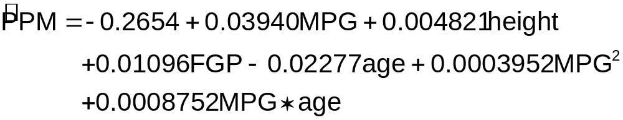
This model is for the entire population. Other models (including ones not discussed here) are probably justifiable as well. Also, no model will be perfect. The key aspects for choosing this model are: 1) No large departures from the underlying regression model assumptions, 2) All terms are at least marginally significant, 3) There are no influential observations that have a large effect on the model.

